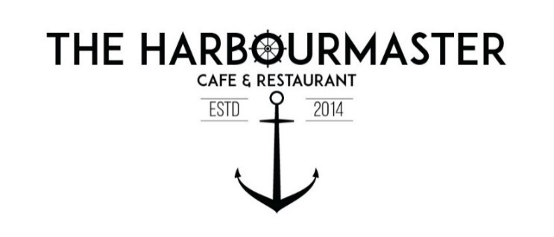

**BREAKFAST**

ALL DAY

**TOASTED SOURDOUGH, CROISSANT OR GLUTEN FREE TOAST 8.50**

**WITH BUTTER & CHOICE OF SPREAD**

RASPBERRY JAM, STRAWBERRY JAM, VEGEMITE OR PEANUT BUTTER

**HOUSEMADE GRANOLA BOWL** - WHIPPED YOGHURT, TOASTED **20.00** COCONUT FLAKES, TREACLE SYRUP & FRESH STRAWBERRIES

**FRENCH TOAST -** HOUSEBAKED JAPANESE MILK BREAD, POPPY SEED **25.00** LEMON CURD, SEASONAL POACHED, MIXED BERRY COMPOTE & MAPLE SYRUP

**FRIED CHICKEN & WAFFLES 20.00**

WHIPPED CHIPOTLE BUTTER & CANADIAN MAPLE

**ADD** BACON **4.50**

**SMASHED AVO 24.00**

WHIPPED FETA, CHERRY TOMATOES, FRIED KALE, PEA HOMMUS, SUMAC & PEPITA DUKAH & GREEN SALSA

**ADD** A POACHED EGG **3.50** **ADD** MUSHROOMS **5.50** (GFA)

**CHILLI SCRAMBLED 22.00**

SERVED ON A CROISSANT, MAMA'S CHILLI, FRIED SHALLOTS, BRAISED CHERRY TOMATOES **ADD** BACON **4.50** **ADD** CHORIZO **6.00**

**EGGS BENNY** - POACHED EGGS, WILTED SPINACH, HOUSEMADE HOLLANDAISE SERVED ON PIGEONWHOLE SOURDOUGH (GFA)  **19.00 ADD** BACON OR HAM **4.50** SALMON **6.00**

**PRAWN AND CHORIZO SCRAMBLE**  **27.00**

PRAWN AND CHORIZO COOKED IN SAMBAL BUTTER, PRAWN BISQUE, BLACK GARLIC AIOLI, FRIED KALE SERVED ON HOUSEBAKED MILK BREAD

**MASTER'S BREAKY** **29.50**

SOURDOUGH, EGGS YOUR WAY, BACON, MUSHROOM,

BRAISED TOMATO, PORK & FENNEL SAUSAGE. HASHBROWN & SPINACH.

**ADD** HALOUMI, AVOCADO **5.50** SMOKED SALMON, CHORIZO **6.00 (GFA)**

**SAUSAGE AND EGG BURGER 17.00** PORK AND FENNEL SAUSAGE PATTY, FLUFFY EGGS, AMERICAN CHEESE, RELISH & TRUFFLE MUSHROOM MAYO (added chilli oil is recommended by the chef)

**ADD** HASHRBOWNS OR BACON **4.50** CHILLI OIL **2.50**

**EGGS YOUR WAY 14.00**

FREE RANGE EGGS ON SOURDOUGH POACHED, FRIED OR SCRAMBLED (GFA)

**SIDES**

- GF BREAD OR EXTRA SOURDOUGH /EXTRA EGG/ SPINACH **3.50**

- BACON/HASH BROWNS/GRILLED TOMATOES **4.50** -THYME ROASTED MUSHROOMS/PAN FRIED HALOUMI/AVOCADO/ PORK & FENNEL SAUSAGE **5.50**

- SMOKED SALMON/SPICY CHORIZO  **6.00**

**LUNCH**

ALL DAY

**PORK BELLY RAMEN -** SLOW COOKED PORK BROTH, RAMEN EGG, **28.00** SWEET CORN, SEAWEED TOPPED WITH SCALLIONS,

**SEAFOOD BASKET -** BATTERED PINKLING, GRILLED TIGER PRAWNS, **32.00** FRIED CALAMARI, BOILED PRAWNS, SERVED WITH CHIPS, HOUSE TARTAR & CHIPOTLE AIOLI

**CHICKEN SOUVALKI 25.00**

MIDDLE EAST SPICED MARINATED CHICKEN, GARLIC SAUCE, PICKLED ONIONS, SALAD MIX AND FETA SERVED WITH CHIPS

**HOT BUFFALO GARLIC CHICKEN BURGER** **25.00**

HOUSEMADE HOT BUFFALO GARLIC SAUCE, OAK LETTUCE, BUTTERMILK RANCH, HOUSE PICKLES, SERVED ON A BRIOCHE BUN WITH CHIPS **ADD** AMERICAN CHEESE 2.50  **ADD** BACON 4.50

**TACOS - GRILLED TIGER PRAWN OR LIGHTLY FRIED CALAMARI** **24.00**

HOUSEMADE GUACAMOLE, CRUNCHY SLAW, PICKLED ONIONS, TROPICAL CHIPOTLE MAYO SERVED WITH CORN RIBS OR CHIPS (GFA)

**MIDDLE EASTERN EGGPLANT**  **27.00**

MIDDLE EAST SPICED ROASTED EGGPLANT, TAHINI INFUSED BUTTER BEAN (GFA) PUREE, PEPPER SALSA, HERB OIL, SMOKED PINE NUTS SERVED WITH CIABATTA

**MISO STEAK SANDWHICH** **29.00**

MARINATED PORTERHOUSE, BELL PEPPER SALSA, CHILLI CRISP MAYO, SALSA VERDE ON A CIABATTA, TOPPED WITH GRATED PARMESAN SERVED WITH CHIPS (GFA)

**DRINKS**

**HOT DRINKS**

**SMALL LARGE TAKE AWAY**

**LONG BLACK 4.5 5.5 5.5**

**FLAT WHITE 4.5 5.5 6.0**

**ESPRESSO 4.0 5.0 5.0**

**LATTE 4.5 5.5 6.0**

**CAPPUCCINO 4.5 5.5 6.0**

**CHAI LATTE 5.0 6.0 6.5**

**HOT CHOCOLATE 4.5 5.5 6.0**

**MOCHA 5.0 6.0 6.5**

**DIRTY HIPPIE 4.5 5.5 6.5**

**WHITE HOT CHOCOLATE 4.5 5.5 6.0**

**MATCHA 5.5 6.5 6.5**

**TUMERIC LATTE 5.5 6.5 6.5**

**POT OF TEA EB/EG/LG/GT/P/CHAI TEA 6.0 6.0**

**COLD DRINKS**

**COKE 5 ICED CHOCOLATE 9**

**COKE NO SUGAR 5 ICED COFFEE 9**

**DIET COKE 5 ICED LATTE 7 VANILLA COKE MILKSHAKE 8**

**SPRITE 5** CHOCOLATE, CARAMEL, LIME **SPRITE LEMON 5** VANILLA, BANANA, STRAWBERRY

**FANTA 5 GINGER BEER 6**

**ORANGE JUICE 7 LEMON LIME BITTERS 6**

**TROPICAL JUICE 7 ICED MATCHA 7.5**

**MINERAL WATER 6 ICED STRAWBERRY MATCHA 9**